

**BIONIC ENGINEERS**

Bengaluru, Karnataka, India



AN

INTERNSHIP REPORT

ON

“Website for Sri Maruthi Pharma”

#### Bachelor of Engineering

#### In

#### Electronics and Communication Engineering

#### 

#### Submitted by: Nischitha.T. R(4GW18EC061)

#### Jeevitha.K (4GW18EC032)

#### Nayana.K.S (4GW18EC056)

#### Saloni.S (4GW18EC085)

#### 

**GSSS Institute of Engineering and Technology for Women-Mysore**

## ABOUT THE COMPANY

Bionics or biologically inspired engineering is the application of biological methods and systems found in [nature](https://en.wikipedia.org/wiki/Nature) to the study and design of [engineering](https://en.wikipedia.org/wiki/Engineering) systems and modern [technology](https://en.wikipedia.org/wiki/Technology).

The word *bionic*, coined by [Jack E. Steele](https://en.wikipedia.org/wiki/Jack_E._Steele) in August 1958, is a [portmanteau](https://en.wikipedia.org/wiki/Portmanteau) from biology and electronicsthat was popularized by the 1970s U.S. television series [The Six Million Dollar Man](https://en.wikipedia.org/wiki/The_Six_Million_Dollar_Man) and [The Bionic Woman](https://en.wikipedia.org/wiki/The_Bionic_Woman), both based upon the novel [Cyborg](https://en.wikipedia.org/wiki/Cyborg_(novel)) by [Martin Caidin](https://en.wikipedia.org/wiki/Martin_Caidin). All three stories feature humans given various superhuman powers by their [electromechanical](https://en.wikipedia.org/wiki/Electromechanical) implants.

According to proponents of bionic technology, the [transfer of technology](https://en.wikipedia.org/wiki/Technology_transfer) between lifeforms and manufactured objects is desirable because evolutionary pressure typically forces living organisms--fauna and flora--to become optimized and efficient. For example, dirt- and water-repellent paint (coating) developed from the observation that practically nothing sticks to the surface of the [lotus flower](https://en.wikipedia.org/wiki/Nelumbo) plant (the [lotus effect](https://en.wikipedia.org/wiki/Lotus_effect)).

The term "[biomimetic](https://en.wikipedia.org/wiki/Biomimetics)" is preferred for references to chemical reactions such as reactions that, in nature, involve biological [macromolecules](https://en.wikipedia.org/wiki/Macromolecules) (e.g., enzymes or nucleic acids) whose chemistry can be replicated *in vitro* using much smaller molecules.

Examples of bionics in engineering include the hulls of boats imitating the thick skin of dolphins; [sonar](https://en.wikipedia.org/wiki/Sonar), [radar](https://en.wikipedia.org/wiki/Radar), and medical [ultrasound](https://en.wikipedia.org/wiki/Ultrasound) imaging imitating [animal echolocation](https://en.wikipedia.org/wiki/Animal_echolocation).

In the field of [computer science](https://en.wikipedia.org/wiki/Computer_science), the study of bionics has produced [artificial neurons](https://en.wikipedia.org/wiki/Artificial_neurons), [artificial neural networks](https://en.wikipedia.org/wiki/Neural_network),[[3]](https://en.wikipedia.org/wiki/Bionics#cite_note-3) and [swarm intelligence](https://en.wikipedia.org/wiki/Swarm_intelligence). [Evolutionary computation](https://en.wikipedia.org/wiki/Evolutionary_computation) was also motivated by bionics ideas but it took the idea further by simulating evolution [in silico](https://en.wikipedia.org/wiki/In_silico) and producing well-optimized solutions that had never appeared in nature.

It is estimated by [Julian Vincent](https://www.schumachercollege.org.uk/teachers/julian-vincent), professor of [biomimetics](https://en.wikipedia.org/wiki/Biomimetics) at the [University of Bath](https://en.wikipedia.org/wiki/University_of_Bath)'s Department of Mechanical Engineering, that "at present there is only a 12% overlap between [biology](https://en.wikipedia.org/wiki/Biology) and technology in terms of the mechanisms used".

**TABLE OF CONTENTS**

Table of contents i

Overview of the Project 1

About Maruthi Pharma 2

Why Maruthi Pharma 3

Tools Used 4

Implementation 5

Snapshots 23

Bibliography 26

## OVERVIEW OF THE PROJECT

## Project Name: Website For Sri Maruthi Pharma

**Team Members:** **Nischitha.T.R**

**Jeevitha.**K

**Nayana.**K.S

**Saloni.**S

## This project is based on Web Development And its Applications. The main objective of this project is to learn the implementation of HTML, CSS and JavaScript. The basic webpage of this project is created using HTML and styling of the webpage is done using CSS.

## This webpage is about one of the greatest companies of all time

<Sri Maruthi Pharma in Banglore is one of the leading businesses in Surgical

Equipment

Distributors Medical Equipment’s Dealers, Pharmaceutical Distributors>

## ABOUT MARUTHI PHARMA

## 

. 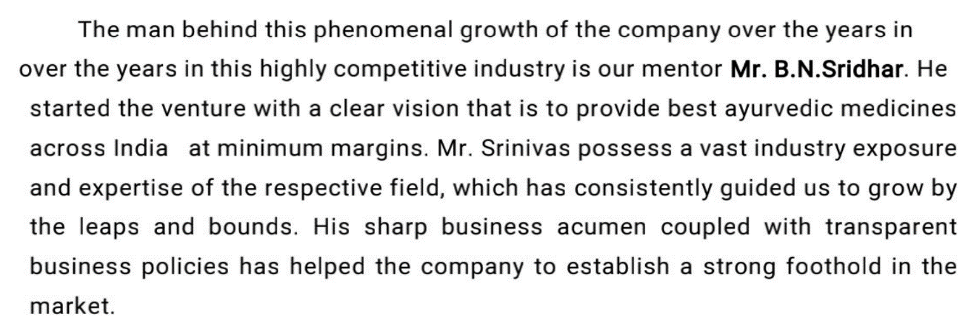

## Why Maruthi Pharma

## 

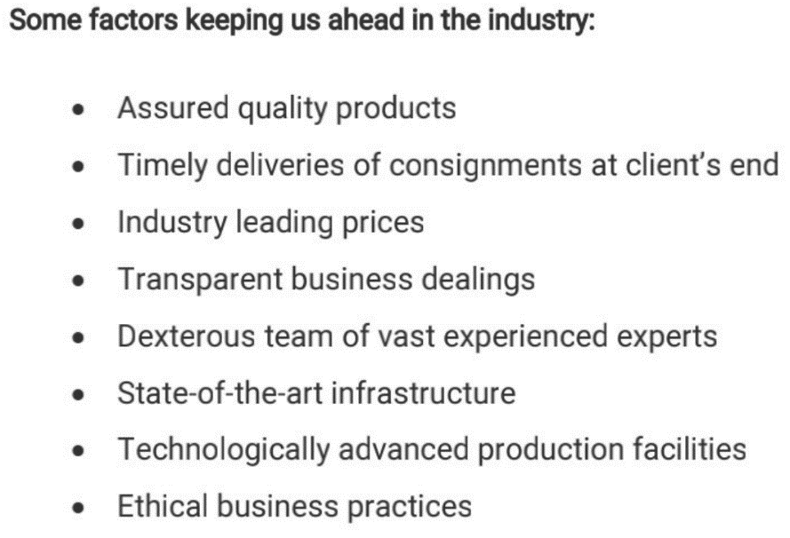

# TOOLS USED

### Software Requirements

* Visual Studio Code 2019.
* Google Chrome or Microsoft Edge of latest version.
* Front End: HTML, CSS, JS (optional)
* Linux 7.1 or Windows XP/7/8/10 OS or Mac OS

### Hardware Requirements

* Pentium 200-MHz computer with a minimum of 64 MB of RAM (128 MB of RAM recommended).
* Monitor with a refresh rate of at least 40Hz for a smooth GUI experience (optional).

# IMPLEMENTATION

# Source Code (P1.HTML):

# 1. <! --ABOUT PAGE HTML-->

# <!DOCTYPE html>

# <html>

# <head>

# <link rel="stylesheet" href="about.css">

# </head>

# <div>

# <img src="mplogo3.png">

# </div>

# <body background= “. /about 1_files/light-blue-background-with-stars-

# vector.jpg"></body>

# <body>

# <ul>

# <li>

# <a href="register.html">Register</a>

# <a href="home.html">Home</a>

# <a href="signin.html">Sign-in</a>

# <a href="contact.html">contact-us</a>

# </li>

# </ul>

# <h1>MARUTHI PHARMACY</h1>

# <hr>

# <h2>Sri Maruthi Pharma in Bangalore is one of the leading businesses in Surgical Equipment Dealers. Also known for Surgical Equipment Dealers, Pharmaceutical Product Distributors, Medical Equipment Dealers, Pharmaceutical Distributors Surgical Item Dealers, Medicine Distributors, Medical Product Dealers, Generic Medicine Wholesalers and much more.

# </h2>

# <hr>

# <h3>SMP OR SRI MARUTHI PHARMA ARE DEALERS IN:</h3>

# 

# <li>

# <ul>*Chemists</ul>

# <ul>*Surgical Equipment Dealers</ul>

# <ul>*Pharmaceutical Product Distributors</ul>

# <ul>*Medical Equipment Dealers</ul>

# <ul>*Pharmaceutical Distributors</ul>

# <ul>*Pharmaceutical Product Manufacturers</ul>

# <ul>*Medicine Wholesalers</ul>

# <ul>*Surgical Face Mask Dealers</ul>

# <ul>*N95 Face Mask Dealers</ul>

# <ul>*Medicine Distributors</ul>

# <ul>*Generic Medicine Distributors</ul>

# <ul>*Pharmaceutical Product Wholesalers and much more</ul>

# </li>

# <hr>

# <p><H2>SMP is a company, established under a mission of service to

# humanity, we provide a wide range of pharmaceuticals and we are building

# reputation of quality and integrity known around the world.

# The products that we supply at SMP Meets the best safety and quality standards. We are being

# audited regularly by officials to ensure that the highest safety and quality criteria were met. </H2></p>

# </body>

# </html>

# 2. <!--CONTACTUS PAGE HTML-->

# <!DOCTYPE html>

# <html>

# <head>

# <link rel="stylesheet" href="contact.css">

# </head>

# <body background= “. /about 1_files/light-blue-background-with-stars-

# vector.jpg" "></body>

# <body>

# <ul>

# 

# <li>

# <a href="register.html">Register</a>

# <a href="HOME.html">Home</a>

# <a href="signin.html">Sign-in</a>

# <a href="about.html">about</a>

# </li>

# </ul>

# <h4>For any information<br>

# </h4>

# <a href="https://wa.me/9535807343">

# <i class=fa fa-WhatsApp" id="WhatsApp"></i>

# 

# <style>

# . WhatsApp float {

# position: fixed;

# bottom:40px;

# right:20px;

# }

# </style>

# <div class="WhatsApp float">

# <a href="https://wa.me/919535807343" target="_blank"><img src="http://assets.stickpng.com/images/580b57fcd9996e24bc43c543.png" width="50px" class="whatsapp_float_btn"/></a>

# </div>

# <p>Name: Maruthi<br>

# contact us via email: pharma@gmail.com<br>

# phone number:9535807343<br><br>

# </p>

# <h3> for any queries/to chat live with us click on watsapp button</h3>

# </body>

# </html>

# 3. <! --HOME PAGE HTML-->

# <!DOCTYPE html>

# <html>

# <head>

# <link rel="stylesheet" href="home.css">

# </head>

# <body background="https:// about 1_files/light-blue-background-with-stars-

# vector.jpg "></body>

# <body>

# <ul>

# <li>

# <a href="register.html">Register</a>

# <a href="contact.html">Contact-us</a>

# <a href="signin.html">Signin</a>

# <a href="about.html">about</a>

# </li>

# </ul>

# <h1>

# <hr>

# <h3>SMP OR SRI MARUTHI PHARMA ARE DEALERS IN:</h3>

# <li>

# <ul>*Chemists</ul>

# <ul>*Surgical Equipment Dealers</ul>

# <ul>*Pharmaceutical Product Distributors</ul>

# <ul>*Medical Equipment Dealers</ul>

# <ul>*Pharmaceutical Distributors</ul>

# <ul>*Pharmaceutical Product Manufacturers</ul>

# <ul>*Medicine Wholesalers</ul>

# <ul>*Surgical Face Mask Dealers</ul>

# <ul>*N95 Face Mask Dealers</ul>

# 

# <ul>*Medicine Distributors</ul>

# <ul>*Generic Medicine Distributors</ul>

# <ul>*Pharmaceutical Product Wholesalers and much more</ul>

# </li>

# <hr>

# </h1>

# </body>

# </html>

# 4.! --REGISTER PAGE HTML-->

# <!DOCTYPE html>

# <html>

# <head>

# <link rel="stylesheet" href="register.css">

# </head>

# <body background=" about 1_files/light-blue-background-with-stars-

# vector.jpg "></body>

# <body>

# <ul>

# <li>

# <a href="signIn.html" title="This will redirect to sign-in page">Sign-In</a>

# <a href="HOME.html" title="This will redirect to home page">Home</a>

# <a href="contact.html" title="This will redirect to contact page">Contact-us</a>

# <a href="about.html" title="This will redirect to about page">About</a>

# </li>

# </ul>

# <h1 title="Please Register your account">SMP</h1>

# <h2 title="Please Register your account->">Start Registering. </h2>

# <div>

# <form method="POST" autocompletes="on" style="color: rgb (128, 0, 100);">

# <label for="name" ><b>User Name:</b></label><br>

# 

# <input type="text" id="name" required title="Please input your name"><br>

# <label for="num"><b>Contact:</b></label><br>

# <input type="tel" id="num" required title="Enter your contact number"><br>

# <label for="mail"><b>Mail-Id:</b></label><br>

# <input type="email" id="mail" required title="Enter your personal mail id"><br>

# <label ><b>Gender:</b></label><br>

# <input type="radio" id="m" value="male" title="Enter your gender">

# <label for="m"><b>Male</b></label>

# <input type="radio" id="f" value="female" title="Enter your gender">

# <label for="f"><b>Female</b></label><br>

# <label for="password"><b>Password:</b></label><br>

# <input type="password" id="password" required title="Enter your

# password"><br><br>

# <input type="reset" value="Reset" title="Click this to reset everthing">

# <input type="submit" value="Submit" title="Click this to submit">

# <p title="Sign-in below" ><b>Already have an account?</b>

# <a href="SignIn.html" title="This will redirect to sign-in page" style="font-size:

# 17px;color: black;">Sign-In</a></p>

# </form>

# </div>

# </body>

# </html>

# 5. <!-- SIGN IN PAGE -->

# <!DOCTYPE html>

# <html>

# <head>

# <link rel="stylesheet" href="Signin.css">

# </head>

# <body background="https:// about 1_files/light-blue-background-with-stars-

# vector.jpg "></body>

# <body>

# 

# <ul>

# <li>

# <a href="register.html" title="This will redirect to register page">Register</a>

# <a href="HOME.html" title="This will redirect to home page">Home</a>

# <a href="contact.html" title="This will redirect to contact page">Contact-

# us</a>

# <a href="about.html" title="This will redirect to about page">About</a>

# </li>

# </ul>

# <h1>WELCOME</h1>

# <h2>To Sri Maruthi Pharma. </h2>

# <div>

# <form method="POST" autocompletes="on" style="color: rgb (128, 0, 100);">

# <label for="name" ><b>User Name:</b></label><br>

# <input type="text" id="name" required title="Please input your registered name"><br>

# <label for="password"><b>Password:</b></label><br>

# <input type="password" id="password" required title="Please input your

# password"><br><br>

# <input type="reset" value="Reset" title="Click this to reset everthing"> <input

# type="submit" value="Submit" title="Click this to submit">

# </form>

# <p title="Register below"><b>Don't have any account? </b><a href="Register.html"

# title="This will redirect to register page" style="font-size: 17px; color:

# black;">Register</a></p>

# </div>

# </body>

# </html>

# IMPLEMENTATION

# Source Code (P1.CSS+P1.JS (if used)):

# 1./CONTACT US PAGE CSS/

# body {

# 

# background-attachment: fixed;

# background-repeat: no-repeat;

# background-size: cover;

# }

# ul a {

# text-decoration: none;

# list-style-type: none;

# color: rgb (128, 0, 100);

# font-family: Arial, Helvetica, sans-serif;

# float: right;

# margin-right: 120px;

# border: 2px outset blue;

# margin-top: 40px;

# padding: 5px;

# }

# li a: hover

# {

# background-color: transparent;

# text-decoration: none;

# font-size: 20px;

# font-family: cursive;

# 

# opacity: 0.7;

# color: rgb (128, 0, 100);

# }

# h4

# {

# font-size: 50px;

# font-family: cursive;

# color: rgb(128, 0, 100);

# }

# p {

# font-size: 20px;

# font-family: cursive;

# color: rgb(3, 3, 17);

# }

# . con

# {

# height: 700px;

# width: 100%;

# margin-left: -100px;

# margin-top: -250px;

# }

# 2. /HOME PAGE CSS/

# body {

# 

# background-attachment: fixed;

# background-repeat: no-repeat;

# background-size: cover;

# }

# ul a{

# text-decoration: none;

# list-style-type: none;

# color: rgb(128, 0, 100);

# font-family: Arial, Helvetica, sans-serif;

# float: right;

# margin-right: 120px;

# border: 2px outset blue;

# margin-top: 40px;

# padding: 5px;

# }

# li a: hover

# {

# background-color: transparent;

# text-decoration: none;

# font-size: 20px;

# font-family: cursive;

# 

# opacity: 0.7;

# color: rgb (128, 0, 100);

# }

# h1{

# font-size: 50px;

# font-family: cursive;

# color: rgb (128, 0, 100);

# text-align: center;

# margin-top: 200px;

# }

# h3{

# font-size: 20px;

# font-family:cursive;

# 

# color: rgb(128, 0, 100);

# text-align: LEFT;

# margin-top: 100px;

# }

**3./REGISTER PAGE CSS/**

body {

background-attachment: fixed;

background-repeat: no-repeat;

background-size: cover;

}

h1

{

font-size: 70px;

font-family: cursive;

color: rgb(128, 0, 100);

}

h2{

font-size: 50px;

font-family: cursive;

color: black;

}

ul a{

text-decoration: none;

list-style-type: none;

color: rgb(128, 0, 100);

font-family: Arial, Helvetica, sans-serif;

float: right;

margin-right: 120px;

border: 2px outset blue;

margin-top: 40px;

padding: 5px;

}

li a: hover

{

background-color: transparent;

text-decoration: none;

font-size: 20px;

font-family: cursive;

background-image: url('bi2.jpg');

opacity: 0.7;

color: rgb (128, 0, 100);

}

div

{

width: 200px;

height: 300px;

border: 5px groove blue;

margin: -180px 200px 200px 650px;

background-image: url('bi2.jpg');

opacity: 0.7;

}

4./SIGN IN PAGE CSS/

body {

background-attachment: fixed;

background-repeat: no-repeat;

background-size: cover;

}

div

{

width: 200px;

height: 200px ;

border: 5px groove blue;

margin: -180px 200px 200px 650px;

opacity: 0.7;

}

ul a {

text-decoration: none;

list-style-type: none;

color: rgb (128, 0, 100);

font-family: Arial, Helvetica, sans-serif;

float: right;

margin-right: 120px;

border: 2px outset blue;

margin-top: 40px;

padding: 5px;

}

li a: hover

{

background-color: transparent;

text-decoration: none;

font-size: 20px;

font-family: cursive;

opacity: 0.7;

color: rgb (128, 0, 100);

}

h1

{

font-size: 70px;

font-family: cursive;

color: rgb (128, 0, 100);

}

h2{

font-size: 50px;

font-family: cursive;

color: rgb(128, 0, 100);

}

.image1

{

margin-top: -350px;

margin-left: 80px;

}

5**./ABOUT PAGE IN CSS/**

body {

background-attachment: fixed;

background-repeat: no-repeat;

background-size: cover;

}

ul a {

text-decoration: none;

list-style-type: none;

color: rgb (128, 0, 100);

font-family: Arial, Helvetica, sans-serif;

float: right;

margin-right: 120px;

border: 2px outset blue;

margin-top: 40px;

padding: 5px;

}

li a: hover

{

background-color: transparent;

text-decoration: none;

font-size: 20px;

font-family: cursive;

opacity: 0.7;

color: rgb (128, 0, 100);

}

h1{

font-size: 50px;

font-family: cursive;

color: rgb(128, 0, 100);

text-align: center;

margin-top: 200px;

}

h3{

font-size: 20px;

font-family: cursive;

color: rgb(128, 0, 100);

text-align: LEFT;

margin-top: 100px;

}

div

{

height: 2%;

width: 2%;

float: left;

margin-top: -30px;

margin-left: -256px;

}

# IMPLEMENTATION

# Snapshots:

# 1. SIGN IN

# 

# 2. REGISTER

# 

**3. HOME**

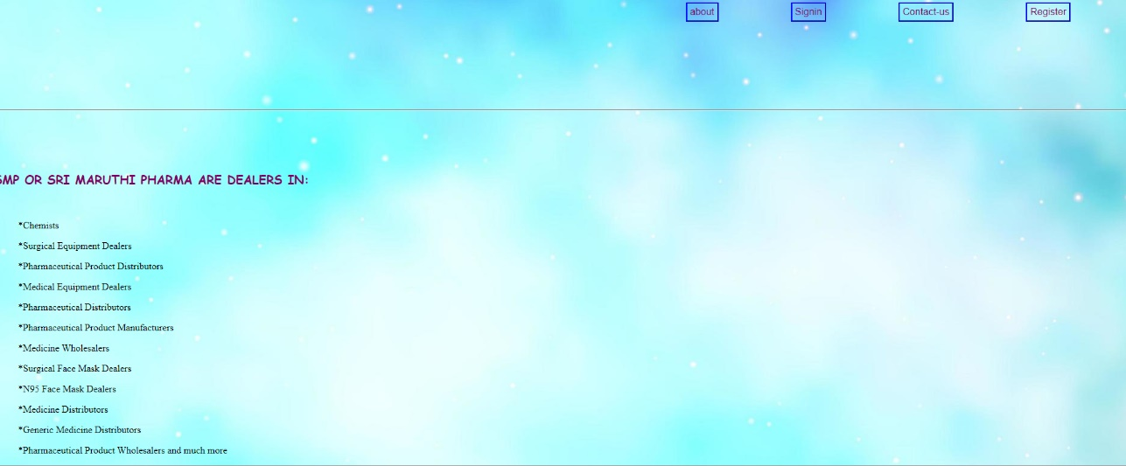

**4.CONTACT**

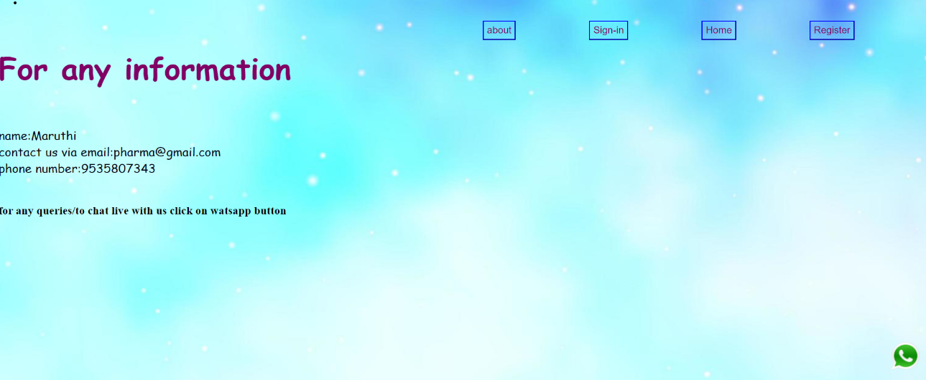

**5. ABOUT**



**BIBLIOGRAPHY**

* https://[www.w3schools.com](http://www.w3schools.com/)
* https://[www.geeksforgeeks.org](http://www.geeksforgeeks.org/)
* https://freefrontend.com

## About my TEAM

<include your team mates’ names and the role played by the teammates>

#### Nischitha.T. R 4GW18EC061 (HTML &CSS for about page)

#### Jeevitha.K 4GW18EC032 (HTML & CSS for contact page)

#### Nayana.K. S 4GW18EC056 (HTML & CSS for sign in page)

#### Saloni.S 4GW18EC085 (HTML & CSS for home page)